**HELPIFY**

**Database**   
**Project Documentation**

By

ISAIAH ANTHONY P. BRIONES

ARJONEL M. MENDOZA, MIT   
Lecturer

**PROJECT OVERVIEW**   
 GUIDE is a user-friendly time management application designed to maximize daily learning for both teachers and students. In addition to offering an inbuilt timer to monitor study periods and breaks, it assists users in creating and organizing to-do lists for educational assignments. Users can increase productivity and learning results by using GUIDE to effectively organize their daily educational tasks, maintain attention, and develop their time management skills.. This database system serves as a practical implementation of the concepts learned in the Database Management System course, such as database design, SQL scripting, and data manipulation.

**ENTITY-RELATIONSHIP DIAGRAM (ERD)**   
 The ERD represents key entities in GUIDE, including Users, User Activity, and Page Session. Each entity has attributes essential for data management.

|  |
| --- |
|  |

Figure 1. Entity Relationship Diagram

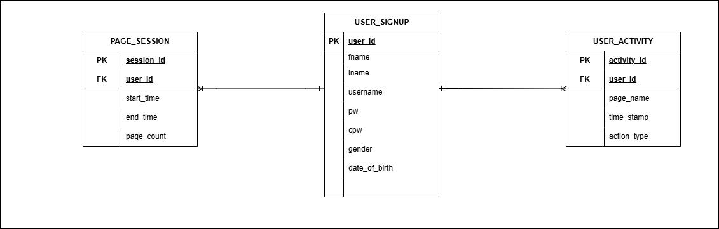

Figure 2. Entity Relationship Diagram

**Entities and their Relationships**

|  |  |  |
| --- | --- | --- |
| **1.** | **Users and User Activity** | |
| • | **Type**: One-to-Many (1:N) |
| • | **Description**: Each user can have one or more user activity, but each user activity must only |

belong to one user.

|  |  |  |
| --- | --- | --- |
| **2.** | **Users and Page Session** | |
| • | **Type:** One-to-Many (1:N) |
| • | **Description:** Each user can have multiple page session, but each page session must be |

associated to only one customer.

**SQL SCRIPTS**

● Create Database

**CREATE DATABASE USER_DB;**

● Use databases

**USE user_db;**

● Create Tables

**CREATE TABLE USER_SIGNUP (**   
**user_id INT AUTO_INCREMENT PRIMARY KEY,**   
**fname VARCHAR(255) NOT NULL,**   
**lname VARCHAR(255) NOT NULL,**   
**username VARCHAR(255) NOT NULL,**   
**pw VARCHAR(255) NOT NULL,**   
**cpw VARCHAR(255) NOT NULL,**

**gender CHAR(1),**   
 **date_of_birth DATE**   
**);**

**CREATE TABLE USER_ACTIVITY (**   
 **activity_id INT AUTO_INCREMENT PRIMARY KEY,**   
 **user_id INT,**   
 **page_name VARCHAR(255),**   
 **timestamp TIMESTAMP DEFAULT CURRENT_TIMESTAMP,**   
 **action_type VARCHAR(50),**   
 **FOREIGN KEY (user_id) REFERENCES user_signup(user_id) );**

**CREATE TABLE PAGE_SESSION (**   
 **session_id INT AUTO_INCREMENT PRIMARY KEY,**   
 **user_id INT,**   
 **start_time TIMESTAMP DEFAULT CURRENT_TIMESTAMP,**   
 **end_time TIMESTAMP NULL,**   
 **page_count INT DEFAULT 0,**   
 **FOREIGN KEY (user_id) REFERENCES user_signup(user_id) );**   
*.*

**Here are the QUERIES used in the accessing of the database:**

● Inserting a record into the user_activity table.

**- - INSERT INTO user_activity (user_id, page_name, action_type) VALUES (%s, %s, %s)**

● Selecting an active session from the Page_Sessions table.

**- - SELECT session_id FROM Page_Sessions WHERE user_id = %s AND end_time IS NULL**

● Updating a session's page count in the Page_Sessions table.

**- - UPDATE Page_Sessions SET page_count = page_count + 1 WHERE session_id = %s**

● Inserting a new session into the Page_Sessions table.

**- - INSERT INTO Page_Sessions (user_id, page_count) VALUES (%s, %s)**

● Retrieving user credentials from the USER_SIGNUP table.

**- - SELECT * FROM USER_SIGNUP WHERE username = %s AND pw = %s**

**SAMPLE DATA**

**User_signup Database Data:**

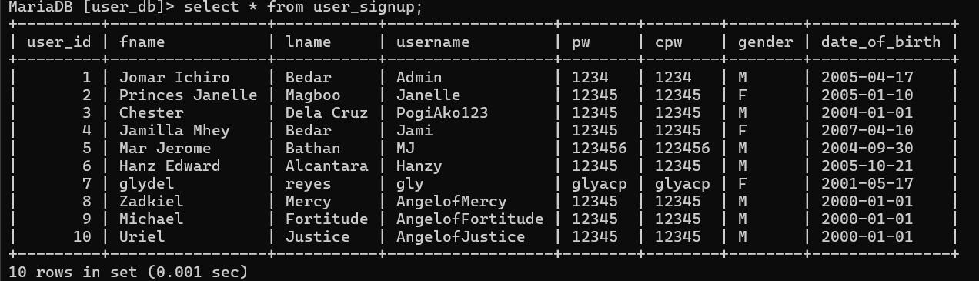

**User_activity Database Data:**

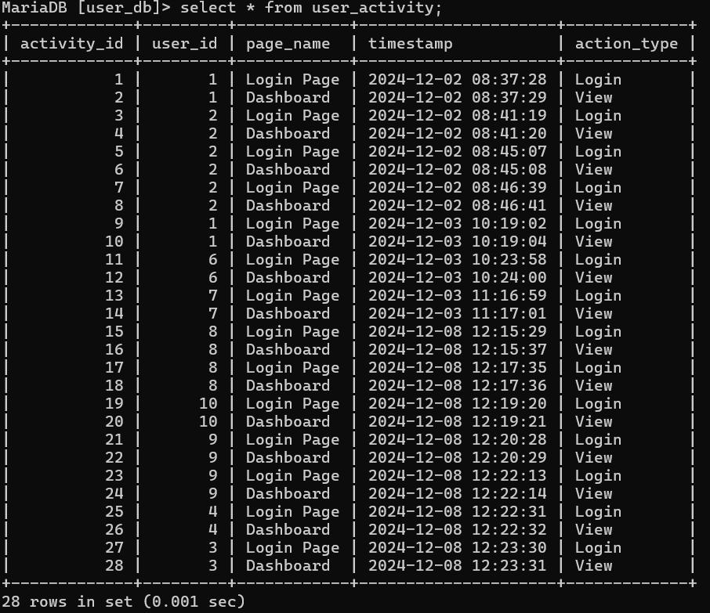

**Page_session Database Data:**

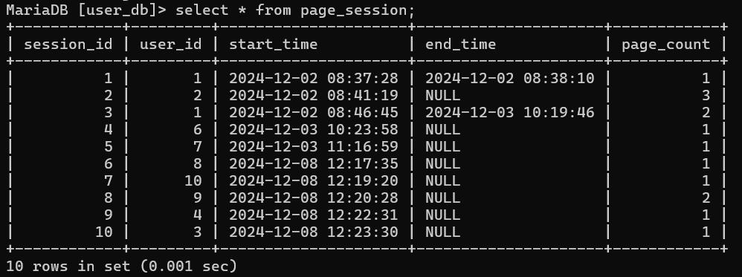

**Functions used in accessing of the database:**

● **LoginPage.py**

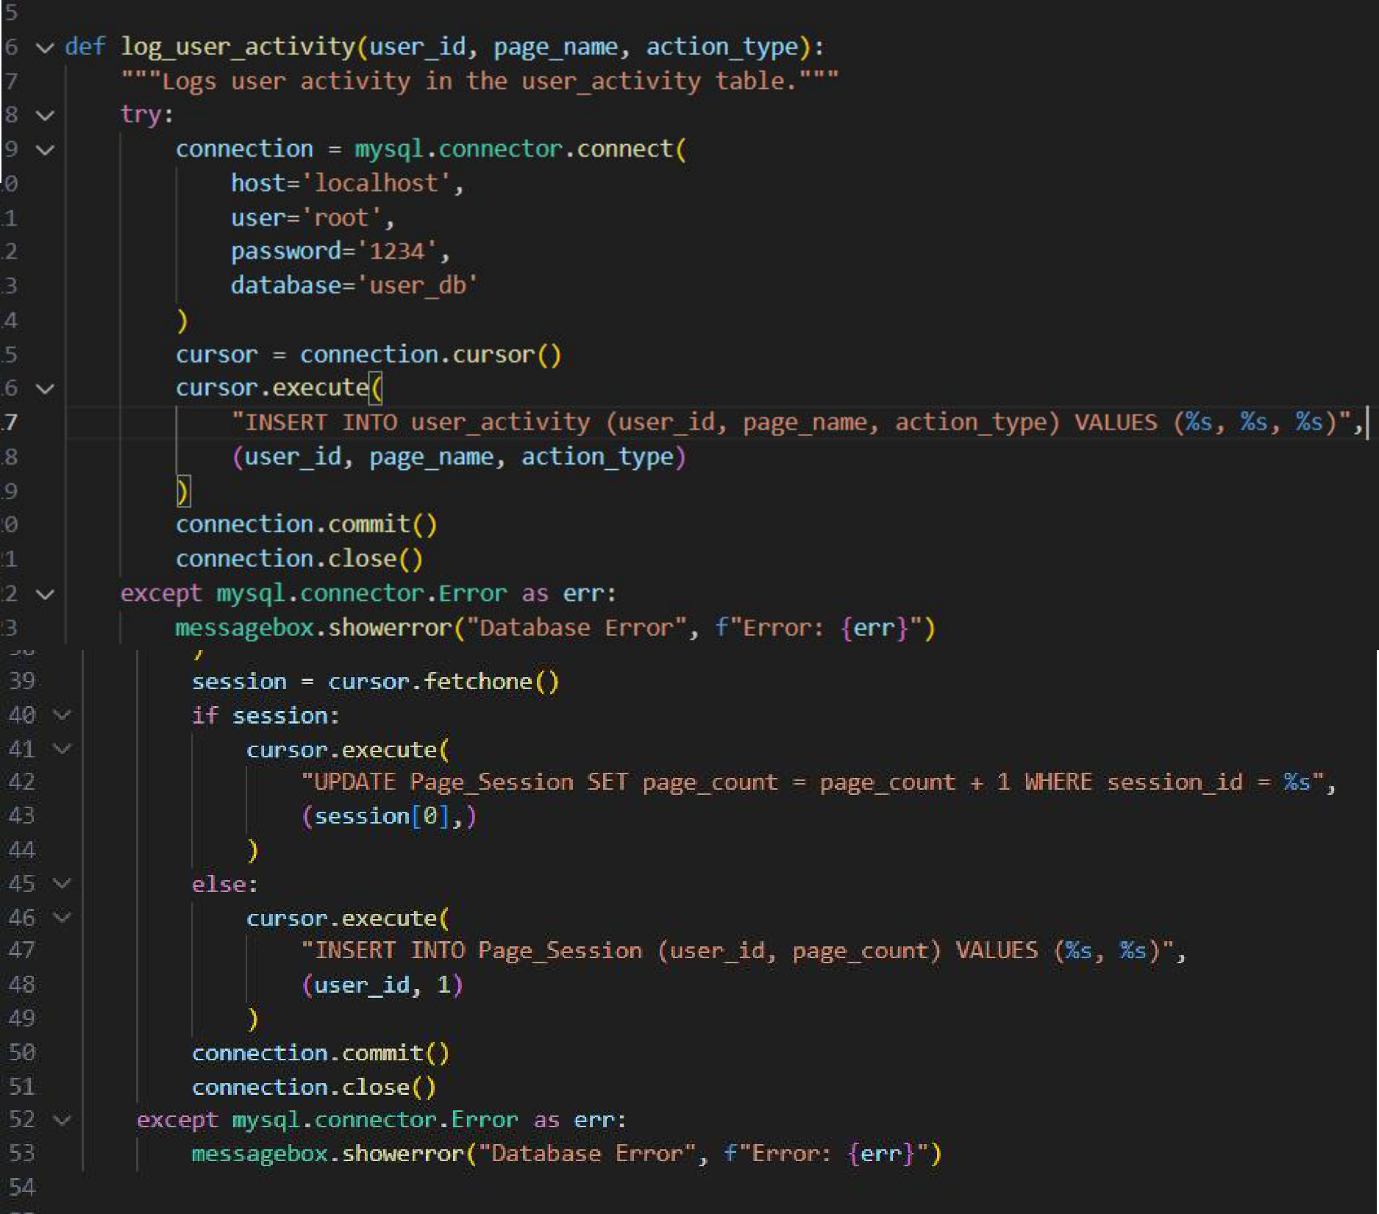

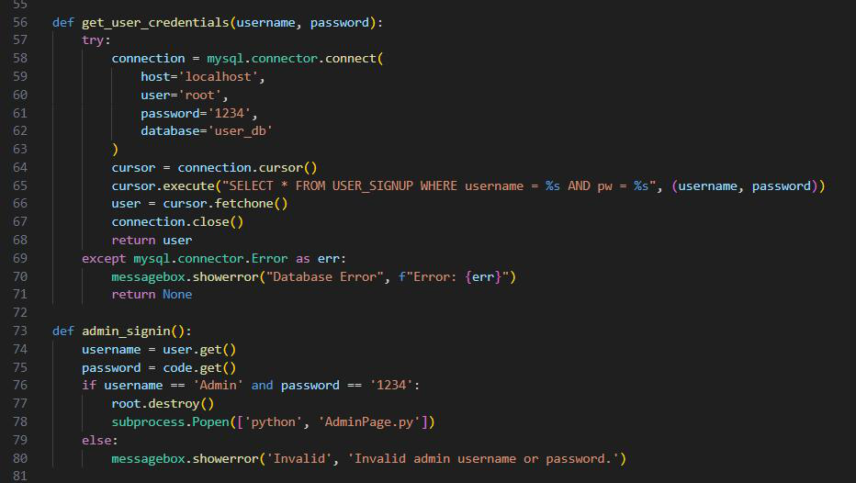

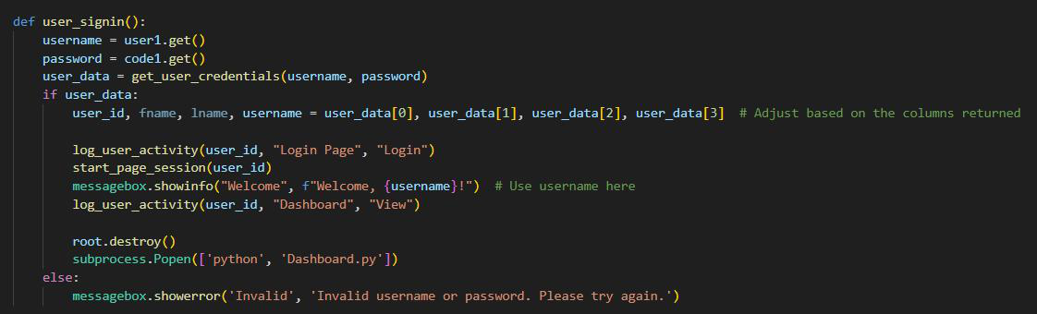

**AdminPage.py**

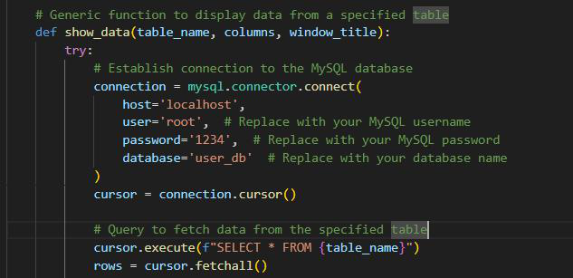

**Dashboard.py**

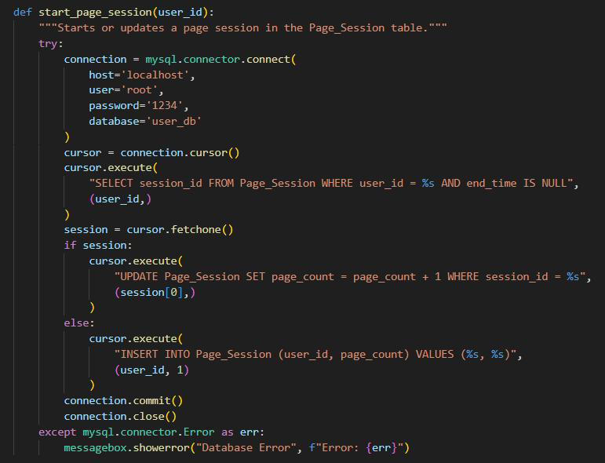

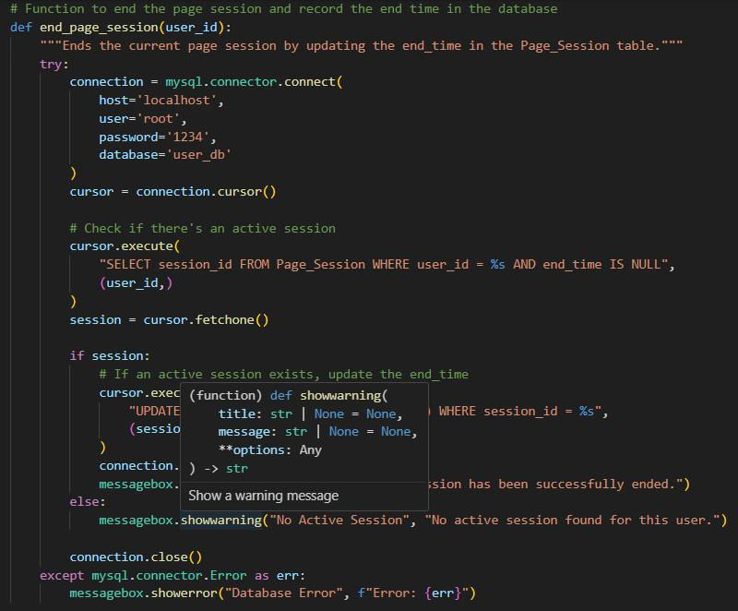

* **Signup.py**

